USER MANUAL PHONERLITE

**CALL BETWEEN EXTENSIONS**

Step 1: Enter the extension number you want to call in "Destination number".

Step 2: Press “Enter” or icon 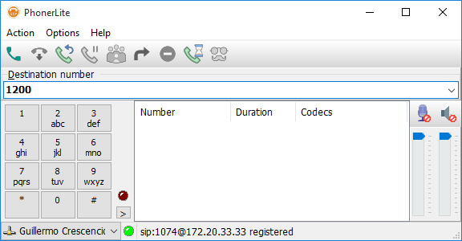.

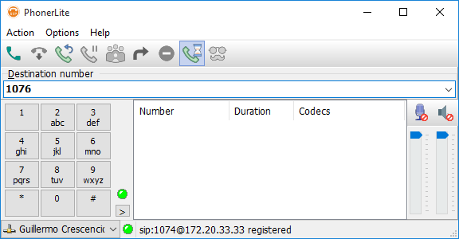

**CALL EXTERNAL NUMBERS.**

Step 1: Enter the extension number you want to call in "Destination number".

Step 2: Press “Enter” or icon .

Step 3: Enter provided PIN followed by the # key.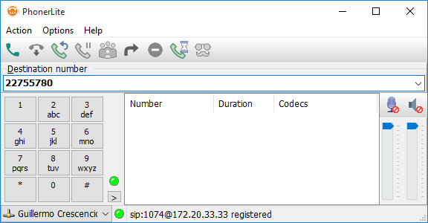

**VOICEMAIL**

Step 1: Enter *97 in “Destination number”.

Step 2: Press “Enter” or icon .

Step 3: Enter provided voicemail password followed by the # key.

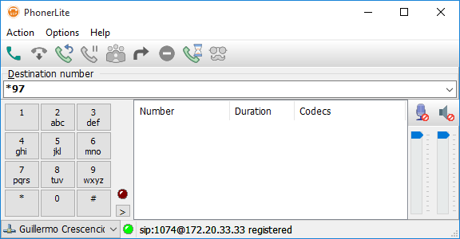

**CALL ON HOLD**

To place a call on hold or resume a previously set call on toggle press the icon 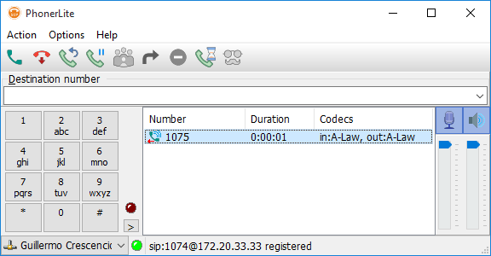.

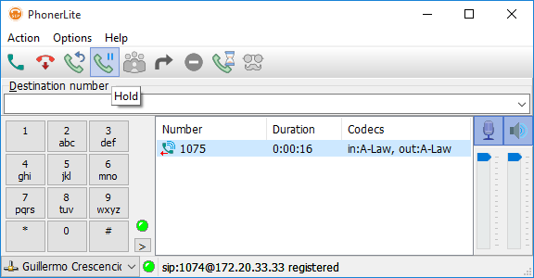

**CALL TRANSFER.**

To transfer a call to another extension or external telephone number:

Step 1: Enter the extension number or telephone number to which the call is transferred in "Destination number".

Step 2: Press “Enter” o icon .

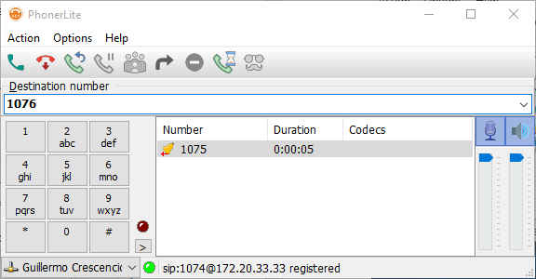

Step 3: Right click on the entered number and select the "Call Transfer" option. 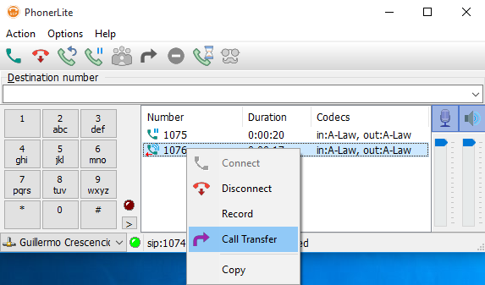

**CONFERENCE**

Step 1: Press the icon .

Step 2: Enter the extension number or telephone number to be added to the call in "Destination number".

Step 3: Press “Enter” or icon .

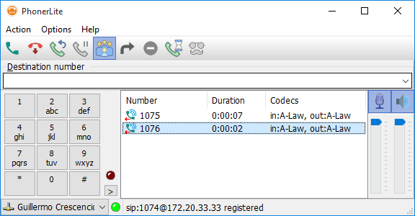

**FORWARDING**

Step 1: Press the icon 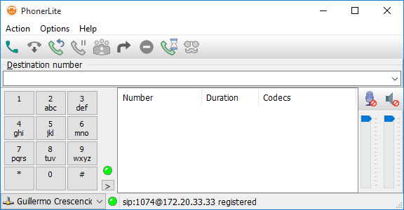

Step 2: Enter the number to which the calls are forwarded.

